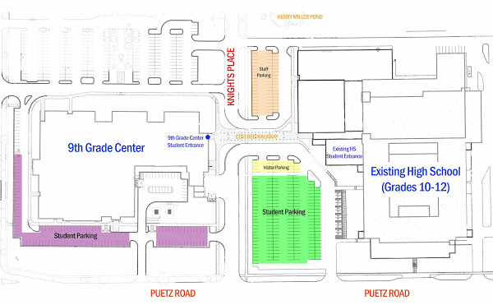
Howell
Ave.

Enter thru Door #14 on the Northwest Corner of the Ninth Grade Center. You will
see signs that say Empowerment Academy.

