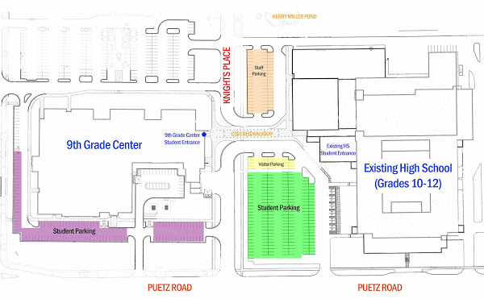
Howell
Ave.

Enter thru Door #14 on the Northwest Corner of the Ninth Grade Center. You will
see signs that say Empowerment Academy.
**Occasionally we will hold classes in the main high school Home Ec room due to conflicts
with scheduling at the Ninth Grade Center. Your registration form will indicate location of class. If a class is scheduled in Home Ec you will enter thru Door #18 on the Northeast Corner of the Main High School building. You will see signs leading to Home Ec/FACE Room.

